Coins on Chess Board

The objective of this problem is to write a program that can determine the maximum number of chess coins of a certain kind that can be placed on a chess board that already has a few other coins placed on it such that none of the coins attack each other. For this problem we will consider only 4 types of chess coins. The coins and their legal moves are as follows. (The moves described are the standard moves in a game of chess. The following content has been reproduced from the site: http://www.chessvariants.com/d.chess/chess.html)
- Rook – The rook moves in a straight line, horizontally or vertically. The rook may not jump over other pieces, that is: all squares between the square where the rook starts its move and where the rook ends its move must be empty
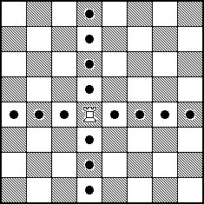

Figure 1: Legal Moves for a Rook

- Bishop – The bishop moves in a straight diagonal line. The bishop may also not jump over other pieces.
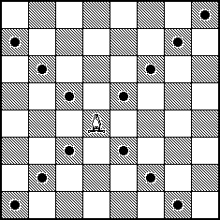

Figure 2: Legal Moves for a Bishop

- Queen – The queen has the combined moves of the rook and the bishop, i.e., the queen may move in any straight line, horizontal, vertical, or diagonal.
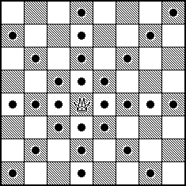

Figure 3: Legal Moves for a Queen

- Knight – The knight makes a move that consists of first one step in a horizontal or vertical direction, and then one step diagonally in an outward direction. The knight jumps: it is allowed that the first square that the knight passes over is occupied by an arbitrary piece. The piece that is jumped over is further not affected by the knight.
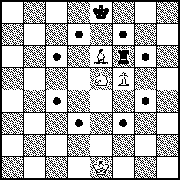

Figure 4: Legal Moves for a Knight (Horse)

For this problem we will represent the Rook by the letter R, the Bishop by the letter B, the Queen by the letter Q and Knight by the letter K. Further to indicate the position of the coins on the board we will use the standard convention in chess of referring to the columns by letters a to h and the rows by numbers 1 to 8 as illustrated in the following figure. Each cell on the board is identified by a column-row combination like a1, d2, c8, h7, etc.
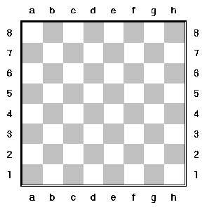

Figure 5: The numbering of rows and columns in a chess board

Now to understand the problem, consider the following example. Assume the following initial layout of the board. (Figure 6)

Q
Q
Q
Figure 6: Initial board layout for the example.

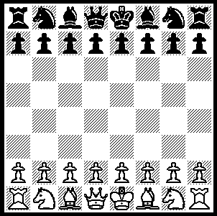
In Figure 6, the chess board contains 3 coins, all queens, placed at the cells b6, c4 and e7. In their current positions none of the queens are attacking each other. Now let’s say we want to place Bishops (B) on this board. The question is what would be the maximum number of bishops that may be placed on this board such that none of the coins placed on the board (Queens and Bishops) attack each other. For example we may place a Bishop each in the cells a1 and d2 without any of the coins on the board attacking each other. The following figure illustrates this.

Q
Q
Q

B
B

Figure 7: Board with two Bishops placed on it

On the board in Figure 7 it is not possible to place a Bishop in h8 or g4 (indicated by the crossed cells) as doing so would put these Bishops under attack from the Bishop already placed in cell a1 and the Queen in cell c4 respectively. Now the problem is to find the maximum number of bishops that may be placed on this board. The position of the Queens cannot be changed as they are part of the initial board layout.
The initial layout of the board will be one of the inputs to the program. As part of the initial layout the board may contain any combination of the 4 coin types (R, B, Q & K) laid out on the board such that none of the coins attack each other. There is no restriction on the number of coins that can be input as part of the initial board layout. The other input to the problem will be the type of coin that needs to be placed on the board. This will be any one of the 4 types. The program needs to find and output the maximum number of coins of that type that may be placed on the board such that no coins attack each other. Additionally, the program also needs to output one such board layout.
The input board layout for the board as shown in Figure 6 will be provided to the program as
b6:Q,c4:Q,e7:Q (Please note that there are no spaces and the comma in the end is optional and may be omitted)
The type of coin to be placed will be input to the program as one of the 4 letters (R, B, Q & K). For the above examples where the problem is to place Bishops the input to the program will be
B
Some more examples of inputs are as follows.
Figure 8: Initial Board Layout: b6:B,f3:R Type of coin to be placed: R
Figure 9: Initial Board Layout: a1:K,b6:B,f3:Q,g7:K Type of coin to be placed: Q
The initial layout may contain any number of coins of any type as long as the coins do not attack each other. The type of coin to be placed can only be of a single type.

B
R
Figure 8: Initial board layout where Rooks need to be placed
B
Q
Figure 9: Initial board layout where Queens need to be placed
K
K

The output from the program should be the maximum number of coins of the input type that can be placed on the board as an integer, such that no coins attack each other. Apart from this the program should also output a board layout with the maximum number of coins. If multiple such layouts are possible any one layout can be output. The format of the output will be the same as that of the input for the initial board layout. The output should include the coins in the initial board layout. (The order of the coins in the output is not important)
The solutions will be evaluated based on the following criteria. Please note that a program will be considered for the ‘Optional Evaluation’ only if the program passes all the test cases under the ‘Mandatory Evaluation’ section. (No requests to publish the test cases for the Mandatory Evaluation section will be entertained when the qualifying round is in progress)

Mandatory Evaluation:
1. Correctness of program (Determined by analyzing the output) - 15
2. Ability to provide the ‘best / near best’ solution (Determined by test cases) - 30
3. Performance of the Program (Determined by test cases) - 15
Optional Evaluation:
4. Algorithm & Implementation (Determined by code review) - 25
5. Code Readability (Formatting, comments, style, coding standards, etc.) - 07
6. Ease of use (Including ease of specifying inputs, etc) - 08
Total: 100
Good Luck and Happy Programming!

